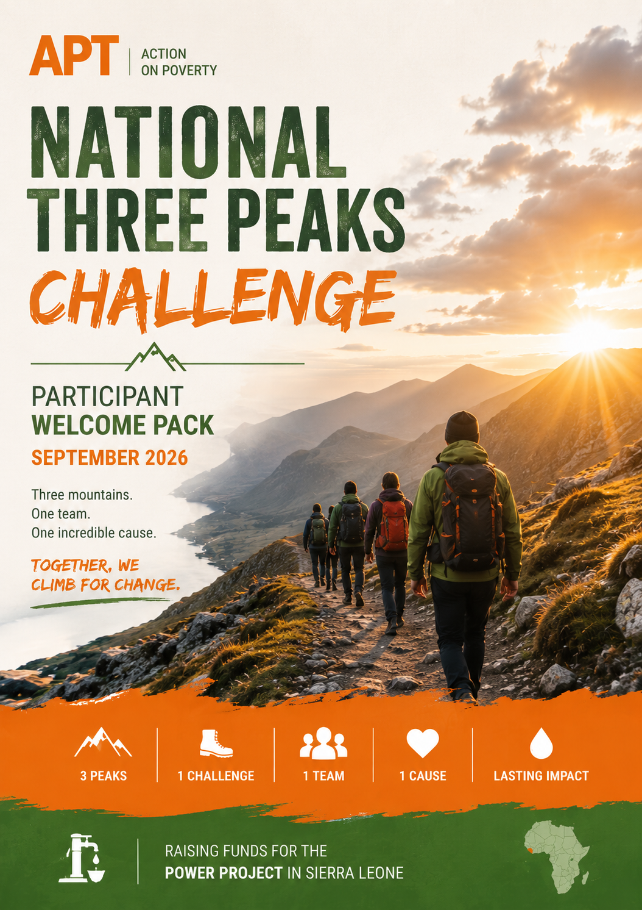

Contents
1. Welcome to the Team!! 2
2. Routes Overview 5
3. Logistics 7
4. Safety 10
5. Fundraising 12
6. Frequently Asked Questions 14

Welcome to the Team!!

More than a mountain challenge
The UK National Three Peaks Challenge is one of Britain's most iconic endurance events. Over the course of 24 hours, participants attempt to climb the highest mountains in Scotland, England and Wales—Ben Nevis (1,345 m), Scafell Pike (978 m) and Snowdon / Yr Wyddfa (1,085 m).
Together, the challenge involves around 37 km (23 miles) of mountain walking, more than 3,000 metres of ascent, and approximately 10 hours of driving between the three national parks. It is physically demanding, mentally challenging and requires teamwork, determination and careful preparation.
But this challenge is about much more than reaching three summits.
Every step you take will help create opportunities for communities thousands of kilometres away in Sierra Leone. By taking part, you become part of a team raising awareness and funds for Action on Poverty's POWER Project, helping rural communities build stronger, more resilient water and sanitation systems while empowering women to become leaders, entrepreneurs and skilled technicians.
This is an adventure with a purpose.

Why we climb
Spending time in the mountains has a way of changing your perspective.

After a few hours on the trail, life becomes surprisingly simple. You think about the weather. Water. Food. The people around you. The path ahead. Things we normally take for granted suddenly become very important.
And in many ways, that is what this challenge is about.

Wherever we live, our lives depend on systems around us working.

We expect clean water when we turn on a tap. We depend on healthy landscapes and coastlines, reliable food systems, viable livelihoods and communities that can respond when things go wrong.

But those systems are increasingly under pressure. Changing weather, flooding, drought, coastal erosion, rising food costs and damaged ecosystems are issues we are becoming more familiar with in the UK and across Europe.

In Sierra Leone, the circumstances and consequences can be much more severe—but some of the underlying questions are recognisable: What happens when the things a community depends on become less reliable? And how do we make communities stronger and better able to respond?

That's where the work we're supporting begins.
The funds raised through the Three Peaks Challenge will support Action on Poverty's work in Sierra Leone, including two initiatives approaching resilience from different directions.

POWER: when water stops flowing
In many rural communities, the problem isn't necessarily that water infrastructure doesn't exist. There may already be a hand pump in the village. The problem starts when it breaks.

Without reliable local maintenance, financing and technical skills, a broken pump can remain out of service for months. The consequences ripple through the whole community—affecting health, education, income and time, with women and girls carrying much of the burden.

POWER is designed to change the system behind the pump.
Working with our local partner MUWODA, young women are training as pump maintenance technicians, sanitation entrepreneurs and community service providers. At the same time, communities are strengthening local water committees and developing maintenance funds and payment systems so they can finance and manage their own water services.
We build the local skills, businesses, leadership and systems that can keep water flowing long after a project ends.

Coastal Roots: protecting what communities depend on
Along Sierra Leone's coast, communities face a different but connected challenge.
People's livelihoods and wellbeing are closely tied to the natural environment around them. When coastal ecosystems deteriorate and climate pressures increase, the effects reach far beyond the environment itself—they affect food, income, security and future opportunities.

Coastal Roots brings environmental restoration and livelihoods together.
Communities are restoring mangroves while developing more resilient ways to earn a living—from climate-resilient agriculture and seed banks to vocational opportunities and sustainable aquaculture.

We help communities protect the natural resources they depend on while creating the skills, opportunities and organisations they need to adapt and thrive.

So why the Three Peaks?

Because resilience isn't built by one person. Over the course of this challenge, we'll experience our own much smaller version of that idea.

The weather may change. We'll get tired. Plans may need to adapt. At some point, someone will probably struggle. We'll rely on preparation, equipment, our driver, our mountain leaders—and especially each other.
We won't reach three summits because one person is strong enough. We'll do it because a team works together.

That same principle sits behind the projects we're supporting.
APT doesn't believe lasting change comes from arriving with a temporary solution. It comes from people having the skills, resources, opportunities and organisations to solve problems themselves.

Your challenge becomes part of theirs
When you join the Three Peaks team, you're doing more than walking 38 kilometres and climbing over 3,000 metres. You're giving people around you a reason to listen.

Your training, your fundraising, the difficult mornings, the bad weather, the kilometres you've walked and eventually the three mountains themselves become opportunities to tell a bigger story.
A story about communities responding to change. About women becoming technicians and entrepreneurs. About people restoring the ecosystems their livelihoods depend on. About practical solutions being built locally rather than imposed from somewhere else. And about what can happen when people come together behind them.

Every step you take, every person you bring into the story and every pound you raise helps us move towards our £8,000 fundraising target and support community-led change in Sierra Leone.

About Action on Poverty
Action on Poverty (APT) is a UK charity that believes lasting change starts with people.
For more than 30 years, we have worked alongside local organisations to help communities tackle the root causes of poverty by strengthening livelihoods, skills, leadership and local organisations.

Rather than focusing on short-term solutions, our partnerships are designed around something more lasting: enabling people and communities to build the knowledge, opportunities and systems they need to shape their own futures.

The Three Peaks Challenge is one small part of that mission.
Through adventure, we're bringing together people here to support people building change there.

Get Involved To register interest or ask questions, contact:
Luc-Antoine Bonte
luc-antoine.bonte@aptuk.org.uk

Routes Overview

The National Three Peaks Challenge takes participants to the highest mountains in Scotland, England and Wales within 24 hours.
Mountain | Height | Distance | Ascent | Estimated Walking Time
Ben Nevis | 1,345 m | 16 km | 1,350 m | 7–9 hours
Scafell Pike | 978 m | 9 km | 900 m | 3–4 hours
Yr Wyddfa (Snowdon) | 1,085 m | 11 km | 725 m | 4–5 hours

Total challenge
- 36 km (23 miles) of walking
- Over 3,400 m of ascent
- Approximately 10–11 hours of driving
- Three National Parks
- Three countries
- One unforgettable weekend

Weekend Itinerary
Please note that timings are approximate and may change depending on weather, traffic and walking pace.
- Friday Evening (~12 am – 1am): Depart Edinburgh and travel overnight to Fort William
- Saturday Early AM (~3–4am): Begin ascent of Ben Nevis (~5–6 hours)
- Saturday Morning (~9–10am): Descend and depart for Wasdale Head
- Saturday Early PM (~2–3pm): Arrive at Wasdale, rest briefly, then climb Scafell Pike (~4 hours)
- Saturday Evening (~7pm): Depart for Snowdonia
- Late Saturday Night (~11pm–12am): Arrive at Snowdon and rest before final ascent
- Sunday Early AM (~3–4am): Snowdon climb to reach the summit for dawn
- Sunday Morning (~8–9am): Descend and celebrate finish

After the Challenge
Once everyone has safely completed the challenge, we'll enjoy breakfast together before returning home.
There will be plenty of time to celebrate, share photos and reflect on an incredible weekend of adventure, teamwork and fundraising.

A few things to remember
The Three Peaks Challenge is demanding, but it isn't a race.
Our priorities throughout the weekend are:
- keeping everyone safe;
- supporting one another as a team;
- respecting the mountains and the local environment;
- enjoying the experience.
Reaching the summit is an achievement. Doing it together for a meaningful cause makes it even more rewarding.

Logistics
Our aim is to make the weekend as straightforward as possible so you can focus on the challenge.
Meeting point
The team will meet in Edinburgh on Friday evening, where we'll introduce ourselves, carry out a final equipment check and brief everyone on the weekend ahead before travelling to Fort William.
The exact meeting location and time will be confirmed a few weeks before the event.

Transport
All transport between the three mountains is organised by Action on Poverty.
We'll travel together throughout the challenge, giving everyone the opportunity to rest between climbs and enjoy the experience as a team.
Transport between the three mountains will be organised. We will also travel from Wales to Edinburgh before the challenge and may be able to collect some participants along the route, depending on location and available space.
Anyone who cannot join a planned pick-up will need to arrange their own travel to Edinburgh. Participants are responsible for their journey home after the challenge, as well as their food, personal equipment and any accommodation needed before or afterwards.

During the challenge
The National Three Peaks Challenge is completed continuously over approximately 24 hours. There is no overnight accommodation during the event. Rest breaks will be taken during the driving sections between mountains, and we'll make planned stops for food, toilets and refreshments.

Food and hydration
Participants are responsible for bringing enough food, snacks and water for the weekend. We'll also stop at service stations where food and drinks can be purchased.
Staying well fuelled and hydrated is one of the most important parts of completing the challenge safely.

What's included?
- Transport between the three mountains
- Experienced challenge leaders
- Safety briefing
- Participant welcome pack
- Training programme
- Fundraising support
- Dedicated WhatsApp group
What's not included?
- Travel to and from Edinburgh
- Accommodation before or after the challenge
- Food and drinks
- Personal walking equipment
- Travel insurance (recommended)

Please note: The itinerary is subject to change depending on weather, traffic and mountain conditions. Our priority is always the safety of the group.

Kit List:
The National Three Peaks Challenge takes place in a mountain environment where weather conditions can change quickly. Even in September, you should be prepared for rain, wind and low temperatures, particularly on the summits.
Please ensure you bring the following:

Essential Clothing
☐ Waterproof jacket (with hood)
☐ Waterproof trousers
☐ Walking boots (well broken-in)
☐ Walking socks (plus a spare pair)
☐ Walking trousers or leggings
☐ Base layer (moisture-wicking)
☐ Mid-layer (fleece or insulated jacket)
☐ Warm hat / Gloves
☐ Buff or neck warmer (optional)

Backpack Essentials
☐ 25–35 L backpack
☐ Water (at least 2 litres)
☐ Lunch and high-energy snacks
☐ Head torch (with spare batteries)
☐ Phone
☐ Portable power bank and charging cable
☐ Personal medication
☐ Blister plasters
☐ Small first aid kit (recommended)
☐ Sunscreen
☐ Lip balm
☐ Sunglasses (optional)
☐ Toilet paper/tissues and a small rubbish bag

For the Journey
Remember that you'll be travelling for around 24 hours.
☐ Comfortable clothes to change into between mountains
☐ Spare socks
☐ Small towel
☐ Extra snacks
☐ Reusable coffee cup (optional)
☐ Neck pillow or travel pillow (optional)
☐ Ear plugs and eye mask (optional)

Nice to Have
These aren't essential but many participants find them useful.
☐ Walking poles
☐ Watch or GPS watch
☐ Electrolyte tablets
☐ Hand sanitiser
☐ Wet wipes

Before You Leave Home
✔ Have you tested your walking boots?
✔ Have you packed waterproofs?
✔ Is your head torch working?
✔ Is your phone fully charged?
✔ Have you filled your water bottles?
✔ Have you told us about any medical conditions or dietary requirements?
✔ Have you set up your JustGiving fundraising page?

A few tips
- Avoid wearing brand-new boots. Blisters are one of the most common reasons people struggle during the challenge.
- Dress in layers. Mountain weather can change rapidly, and you'll warm up quickly while walking.
- Pack light. Bring what you need, but remember you'll carry it all day.
- Keep essentials accessible. Waterproofs, snacks and your head torch should be easy to reach.

Safety

Your safety is our highest priority.
The National Three Peaks Challenge is physically demanding and takes place in a mountain environment where weather conditions can change quickly. While we aim to complete the challenge within 24 hours, our priority will always be the safety and wellbeing of the group—not the clock.

Before the challenge
Preparing well is the best way to stay safe.
We ask all participants to:
- Wear suitable clothing and well-fitting walking boots.
- Read the kit list carefully and come prepared for all weather conditions.
- Inform us of any medical conditions, allergies or injuries before the event.
- Ensure they are physically capable of undertaking a strenuous endurance challenge.
If you are unsure whether this challenge is suitable for you, please speak to your GP before registering.

During the challenge
Everyone has different experience and fitness levels, but we climb as one team.
Our challenge leaders will set the pace, monitor the group and make decisions based on the conditions. Please:
- Stay with the group unless instructed otherwise.
- Follow the guidance of the challenge leaders at all times.
- Tell a leader immediately if you feel unwell, injured or overly fatigued.
- Eat and drink regularly, even if you don't feel hungry or thirsty.
- Look out for one another—small acts of support can make a big difference.
Challenge leaders
The event will be led by experienced mountain leaders who are responsible for the safety of the group.
Their decisions regarding routes, timings or changes to the itinerary are final and will always be made in the interests of participant safety.

If plans change
Safety always comes first.
Severe weather, mountain conditions, road closures or other unforeseen circumstances may require us to change or shorten the itinerary. While our goal is to complete all three peaks, there may be occasions when adapting the plan is the safest decision.

Remember: The objective isn't simply to finish the challenge. It's to finish safely, support one another along the way, and enjoy an unforgettable weekend together.

Our Mountain Code
- Respect the mountains and the weather.
- Respect other walkers and local communities.
- Leave no trace—take all litter home.
- Support your teammates.
- Ask for help early if you're struggling.
- Safety always comes before speed.

Fundraising

The Three Peaks Challenge is more than an adventure—it's an opportunity to create lasting change.
There is no registration fee to take part. Instead, we ask every participant to help raise funds for the POWER project in Sierra Leone. Every donation, no matter the size, helps communities gain reliable access to clean water, improve health, create opportunities for women and build stronger, more resilient futures.
Our suggested fundraising target is £500 per participant.
If you've never fundraised before, don't worry. Most people are surprised by how quickly donations add up once they start asking. You won't be doing this alone—we'll provide guidance, resources and plenty of ideas to help you reach your goal.

Setting up your fundraising page
Each participant will create their own JustGiving fundraising page, linked to our National Three Peaks Challenge team page.
This allows your friends, family and colleagues to support your challenge while contributing towards our shared fundraising goal.
We'll provide everything you need to get started, including suggested text, images and social media content.

How to reach your target
You don't need one person to donate £500.
You need lots of people to support something they believe in.
For example:
- 20 people giving £25 = £500
- 10 people giving £50 = £500
- 50 people giving £10 = £500
Small donations really do make a difference.

Fundraising ideas
There are countless ways to raise money. Here are a few that have worked well in the past.
Share your journey : People love following a challenge.
Post updates from your training, share photos from walks or explain why you've decided to take part. Bringing people along on your journey makes them much more likely to support you.
Ask friends and family: Sometimes the hardest part is simply asking.
A personal message explaining why you're taking on the challenge is often far more effective than a generic social media post.
Get your colleagues involved: Many colleagues are happy to support fundraising through:
- Office collections
- Cake sales or coffee mornings
- Quiz nights
- Raffles
- Casual dress days
- Corporate donations
Organise a fundraising event: A small event can quickly boost your fundraising while bringing people together.
- Pub quiz
- Bake sale
- Charity walk or run
- Games night
- Five-a-side football tournament
- Sponsored challenge

Every donation has an impact
The money you raise helps communities develop the skills and resources to maintain their own water systems and build lasting resilience.
Together, we're helping create healthier communities, greater opportunities for women and stronger local economies.
Every donation—whether it's £5 or £500—is another step towards that goal.

We're here to help
Fundraising can feel daunting at first, but you won't be doing it alone.
We'll provide:
- A personalised JustGiving page
- Social media graphics and templates
- Fundraising tips and ideas
- Regular encouragement and support
- A dedicated WhatsApp group where participants can share ideas and celebrate milestones
If you're ever unsure how to reach your target, just ask. We're here to help every step of the way.

Frequently Asked Questions
Do I need previous mountain experience?
No. You don't need to have completed the National Three Peaks Challenge before. However, you should have a good level of fitness and be comfortable walking for several hours on uneven terrain. Following the recommended training programme will help you prepare.

How fit do I need to be?
The challenge is physically demanding and involves approximately 36 km (23 miles) of walking, over 3,400 metres of ascent and around 24 hours of continuous travel.
You don't need to be an athlete, but you should train regularly in the weeks leading up to the event and feel confident walking in hilly or mountainous terrain.

Is there a registration fee?
No. Instead of paying an entry fee, participants are asked to raise at least £500 to support Action on Poverty's POWER project in Sierra Leone.

Do I have to reach the fundraising target?
We encourage every participant to aim for the £500 target, as this helps maximise the impact of the challenge. We'll provide plenty of fundraising support, ideas and resources to help you get there.

What happens if the weather is bad?
The mountains are unpredictable, and weather conditions can change quickly.
Our challenge leaders will monitor the forecast and make decisions based on the safety of the group. This may mean changing our schedule or, in exceptional circumstances, adapting the route.

What if I can't complete one of the mountains?
Your safety and wellbeing always come first.
If you're unable to continue, we'll work with you to find the safest solution. Completing all three peaks is the goal, but looking after yourself is more important than reaching every summit.

What should I bring?
A full kit list is included later in this guide. At a minimum, you'll need suitable walking boots, waterproof clothing, warm layers, a head torch, food, water and any personal medication.

Will transport be provided?
Yes. Transport between the three mountains is organised by Action on Poverty.
Participants are responsible for arranging their own travel to the meeting point in Edinburgh and their journey home after the challenge.

Where will we sleep?
The challenge is completed continuously over approximately 24 hours, so there is no overnight accommodation during the event.
We'll take regular breaks during the driving sections, but participants should expect a long and demanding weekend with limited sleep.

What if I have a medical condition?
Please let us know as early as possible if you have any medical conditions, allergies or injuries that may affect your participation. All information will be treated confidentially.
If you're unsure whether the challenge is suitable for you, we recommend speaking with your GP before registering.

Can my friends or family join?
Friends and family are very welcome to support your fundraising, but the challenge itself is limited to registered participants due to transport and safety arrangements.

How can I prepare?
The best preparation is to:
- Follow the training programme.
- Wear in your walking boots.
- Test your equipment before the event.
- Stay active in the weeks leading up to the challenge.
- Set up your JustGiving page and begin fundraising early.

Who can I contact if I have questions?
If you have any questions before the event, don't hesitate to get in touch with the Action on Poverty team.
We'll also create a dedicated WhatsApp group where participants can ask questions, share training updates and get to know one another before the challenge.

