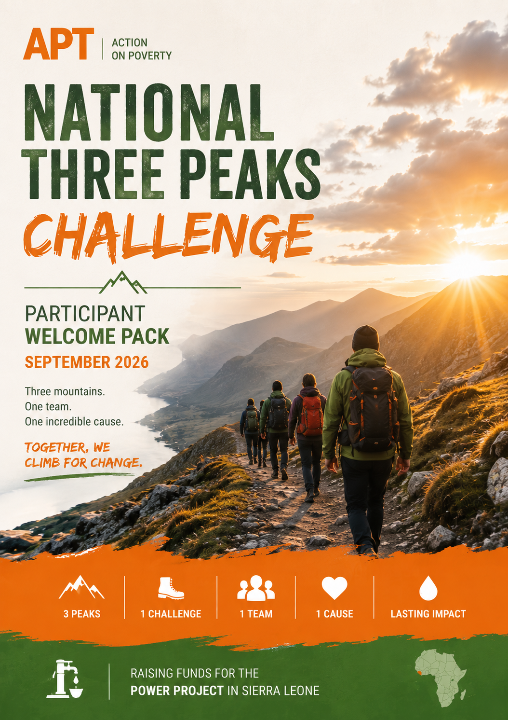

Contents
1. Welcome to the Team!! 2
2. Routes Overview 5
3. Logistics 7
4. Safety 10
5. Fundraising 12
6. Frequently Asked Questions 14

Welcome to the Team!!

More than a mountain challenge
The UK National Three Peaks Challenge is one of Britain's most iconic endurance events. Over the course of 24 hours, participants attempt to climb the highest mountains in Scotland, England and Wales—Ben Nevis (1,345 m), Scafell Pike (978 m) and Snowdon / Yr Wyddfa (1,085 m).
Together, the challenge involves around 37 km (23 miles) of mountain walking, more than 3,000 metres of ascent, and approximately 10 hours of driving between the three national parks. It is physically demanding, mentally challenging and requires teamwork, determination and careful preparation.
But this challenge is about much more than reaching three summits.
Every step you take will help create opportunities for communities thousands of kilometres away in Sierra Leone. By taking part, you become part of a team raising awareness and funds for Action on Poverty's POWER Project, helping rural communities build stronger, more resilient water and sanitation systems while empowering women to become leaders, entrepreneurs and skilled technicians.
This is an adventure with a purpose.

Why we climb
Spending time in the mountains has a way of changing your perspective.
After a few hours on the trail, life becomes surprisingly simple. You think about the next step, the weather, your teammates and whether you've got enough water to reach the summit. The things we often take for granted suddenly become the most important.
Water is one of them.
During this challenge, we'll refill our bottles without thinking twice. At a café, a campsite or a service station, clean water will always be there when we need it.
For many rural communities in Sierra Leone, it isn't that simple.
Many villages already have hand pumps, but when one breaks down, it can remain out of service for months because there is no local system to maintain it. Today, 30–40% of rural water points are estimated to be non-functional, largely because of weak maintenance systems and limited financing.
When that happens, the impact goes far beyond water. Women and girls are usually responsible for collecting it, often walking long distances every day before work or school. Families are more vulnerable to waterborne diseases, children spend less time in education, and communities lose valuable time and opportunities to earn an income. Access to reliable water is closely linked to better health, stronger local economies and greater opportunities for women to participate in community life.
That's why the POWER project is about much more than repairing pumps.
Working with our local partner, MUWODA, the project trains young women as pump maintenance technicians, sanitation entrepreneurs and community service providers. It also strengthens local water committees, introduces community-managed maintenance funds and supports simple payment systems that keep services running long after the project has ended.
The approach is already showing results. Four pilot communities are now operating with community-managed maintenance systems, 931 households are contributing to local maintenance funds, 50 young women are already engaged in training and enterprise development, and more than 2,000 community members have taken part in awareness and mobilisation activities.
By 2028, the project aims to reach 10,000–15,000 people, rehabilitate and maintain more than 20 rural water points, support 100–120 women into technical and economic roles, and reduce water point downtime by 40–60%.
By taking on the Three Peaks Challenge, you're helping make that possible.
Every mile you walk and every pound you raise will help communities develop the skills, confidence and resources to manage their own water services. The result isn't just reliable access to clean water—it's healthier families, more opportunities for women, stronger local businesses and communities that are better equipped to build their own future.
To learn more about the POWER project, its activities and long-term vision, visit the Action on Poverty website.

About Action on Poverty
Action on Poverty (APT) is a UK charity that believes lasting change starts with people, not projects.
For more than 30 years, we've worked alongside local organisations across Africa and Asia to help communities tackle the root causes of poverty. Rather than delivering short-term aid, we invest in local leadership, practical skills and long-term partnerships that enable communities to build their own future.
Our work focuses on creating opportunities—supporting women, young people and people with disabilities to improve livelihoods, strengthen local organisations and become leaders in their own communities. Every programme is designed with local partners, ensuring solutions are rooted in the needs, knowledge and ambitions of the people they serve.
The Three Peaks Challenge is one way of supporting that mission. By bringing people together through adventure, we hope to raise not only funds, but also awareness of the incredible work being led by our partners and the communities they work with.

Get Involved To register interest or ask questions, contact:
Luc-Antoine Bonte
luc-antoine.bonte@aptuk.org.uk

Let’s climb for change – together!

Routes Overview

The National Three Peaks Challenge takes participants to the highest mountains in Scotland, England and Wales within 24 hours.
Mountain | Height | Distance | Ascent | Estimated Walking Time
Ben Nevis | 1,345 m | 16 km | 1,350 m | 7–9 hours
Scafell Pike | 978 m | 9 km | 900 m | 3–4 hours
Yr Wyddfa (Snowdon) | 1,085 m | 11 km | 725 m | 4–5 hours

Total challenge
- 36 km (23 miles) of walking
- Over 3,400 m of ascent
- Approximately 10–11 hours of driving
- Three National Parks
- Three countries
- One unforgettable weekend

Weekend Itinerary
Please note that timings are approximate and may change depending on weather, traffic and walking pace.
- Friday Evening (~12 am – 1am): Depart Edinburgh and travel overnight to Fort William
- Saturday Early AM (~3–4am): Begin ascent of Ben Nevis (~5–6 hours)
- Saturday Morning (~9–10am): Descend and depart for Wasdale Head
- Saturday Early PM (~2–3pm): Arrive at Wasdale, rest briefly, then climb Scafell Pike (~4 hours)
- Saturday Evening (~7pm): Depart for Snowdonia
- Late Saturday Night (~11pm–12am): Arrive at Snowdon and rest before final ascent
- Sunday Early AM (~3–4am): Snowdon climb to reach the summit for dawn
- Sunday Morning (~8–9am): Descend and celebrate finish

After the Challenge
Once everyone has safely completed the challenge, we'll enjoy breakfast together before returning home.
There will be plenty of time to celebrate, share photos and reflect on an incredible weekend of adventure, teamwork and fundraising.

A few things to remember
The Three Peaks Challenge is demanding, but it isn't a race.
Our priorities throughout the weekend are:
- keeping everyone safe;
- supporting one another as a team;
- respecting the mountains and the local environment;
- enjoying the experience.
Reaching the summit is an achievement. Doing it together for a meaningful cause makes it even more rewarding.

Logistics
Our aim is to make the weekend as straightforward as possible so you can focus on the challenge.
Meeting point
The team will meet in Edinburgh on Friday evening, where we'll introduce ourselves, carry out a final equipment check and brief everyone on the weekend ahead before travelling to Fort William.
The exact meeting location and time will be confirmed a few weeks before the event.

Transport
All transport between the three mountains is organised by Action on Poverty.
We'll travel together throughout the challenge, giving everyone the opportunity to rest between climbs and enjoy the experience as a team.
Participants are responsible for arranging their own travel to Edinburgh before the event and their journey home after the challenge.
There is possibility to be picked up on the way to Edinburgh from Mid-Wales.

During the challenge
The National Three Peaks Challenge is completed continuously over approximately 24 hours. There is no overnight accommodation during the event. Rest breaks will be taken during the driving sections between mountains, and we'll make planned stops for food, toilets and refreshments.

Food and hydration
Participants are responsible for bringing enough food, snacks and water for the weekend. We'll also stop at service stations where food and drinks can be purchased.
Staying well fuelled and hydrated is one of the most important parts of completing the challenge safely.

What's included?
- Transport between the three mountains
- Experienced challenge leaders
- Safety briefing
- Participant welcome pack
- Training programme
- Fundraising support
- Dedicated WhatsApp group
What's not included?
- Travel to and from Edinburgh
- Accommodation before or after the challenge
- Food and drinks
- Personal walking equipment
- Travel insurance (recommended)

Please note: The itinerary is subject to change depending on weather, traffic and mountain conditions. Our priority is always the safety of the group.

Kit List:
The National Three Peaks Challenge takes place in a mountain environment where weather conditions can change quickly. Even in September, you should be prepared for rain, wind and low temperatures, particularly on the summits.
Please ensure you bring the following:

Essential Clothing
☐ Waterproof jacket (with hood)
☐ Waterproof trousers
☐ Walking boots (well broken-in)
☐ Walking socks (plus a spare pair)
☐ Walking trousers or leggings
☐ Base layer (moisture-wicking)
☐ Mid-layer (fleece or insulated jacket)
☐ Warm hat / Gloves
☐ Buff or neck warmer (optional)

Backpack Essentials
☐ 25–35 L backpack
☐ Water (at least 2 litres)
☐ Lunch and high-energy snacks
☐ Head torch (with spare batteries)
☐ Phone
☐ Portable power bank and charging cable
☐ Personal medication
☐ Blister plasters
☐ Small first aid kit (recommended)
☐ Sunscreen
☐ Lip balm
☐ Sunglasses (optional)
☐ Toilet paper/tissues and a small rubbish bag

For the Journey
Remember that you'll be travelling for around 24 hours.
☐ Comfortable clothes to change into between mountains
☐ Spare socks
☐ Small towel
☐ Extra snacks
☐ Reusable coffee cup (optional)
☐ Neck pillow or travel pillow (optional)
☐ Ear plugs and eye mask (optional)

Nice to Have
These aren't essential but many participants find them useful.
☐ Walking poles
☐ Watch or GPS watch
☐ Electrolyte tablets
☐ Hand sanitiser
☐ Wet wipes

Before You Leave Home
✔ Have you tested your walking boots?
✔ Have you packed waterproofs?
✔ Is your head torch working?
✔ Is your phone fully charged?
✔ Have you filled your water bottles?
✔ Have you told us about any medical conditions or dietary requirements?
✔ Have you set up your JustGiving fundraising page?

A few tips
- Avoid wearing brand-new boots. Blisters are one of the most common reasons people struggle during the challenge.
- Dress in layers. Mountain weather can change rapidly, and you'll warm up quickly while walking.
- Pack light. Bring what you need, but remember you'll carry it all day.
- Keep essentials accessible. Waterproofs, snacks and your head torch should be easy to reach.

Safety

Your safety is our highest priority.
The National Three Peaks Challenge is physically demanding and takes place in a mountain environment where weather conditions can change quickly. While we aim to complete the challenge within 24 hours, our priority will always be the safety and wellbeing of the group—not the clock.

Before the challenge
Preparing well is the best way to stay safe.
We ask all participants to:
- Wear suitable clothing and well-fitting walking boots.
- Read the kit list carefully and come prepared for all weather conditions.
- Inform us of any medical conditions, allergies or injuries before the event.
- Ensure they are physically capable of undertaking a strenuous endurance challenge.
If you are unsure whether this challenge is suitable for you, please speak to your GP before registering.

During the challenge
Everyone has different experience and fitness levels, but we climb as one team.
Our challenge leaders will set the pace, monitor the group and make decisions based on the conditions. Please:
- Stay with the group unless instructed otherwise.
- Follow the guidance of the challenge leaders at all times.
- Tell a leader immediately if you feel unwell, injured or overly fatigued.
- Eat and drink regularly, even if you don't feel hungry or thirsty.
- Look out for one another—small acts of support can make a big difference.
Challenge leaders
The event will be led by experienced mountain leaders who are responsible for the safety of the group.
Their decisions regarding routes, timings or changes to the itinerary are final and will always be made in the interests of participant safety.

If plans change
Safety always comes first.
Severe weather, mountain conditions, road closures or other unforeseen circumstances may require us to change or shorten the itinerary. While our goal is to complete all three peaks, there may be occasions when adapting the plan is the safest decision.

Remember: The objective isn't simply to finish the challenge. It's to finish safely, support one another along the way, and enjoy an unforgettable weekend together.

Our Mountain Code
- Respect the mountains and the weather.
- Respect other walkers and local communities.
- Leave no trace—take all litter home.
- Support your teammates.
- Ask for help early if you're struggling.
- Safety always comes before speed.

Fundraising

The Three Peaks Challenge is more than an adventure—it's an opportunity to create lasting change.
There is no registration fee to take part. Instead, we ask every participant to help raise funds for the POWER project in Sierra Leone. Every donation, no matter the size, helps communities gain reliable access to clean water, improve health, create opportunities for women and build stronger, more resilient futures.
Our suggested fundraising target is £500 per participant.
If you've never fundraised before, don't worry. Most people are surprised by how quickly donations add up once they start asking. You won't be doing this alone—we'll provide guidance, resources and plenty of ideas to help you reach your goal.

Setting up your fundraising page
Each participant will create their own JustGiving fundraising page, linked to our National Three Peaks Challenge team page.
This allows your friends, family and colleagues to support your challenge while contributing towards our shared fundraising goal.
We'll provide everything you need to get started, including suggested text, images and social media content.

How to reach your target
You don't need one person to donate £500.
You need lots of people to support something they believe in.
For example:
- 20 people giving £25 = £500
- 10 people giving £50 = £500
- 50 people giving £10 = £500
Small donations really do make a difference.

Fundraising ideas
There are countless ways to raise money. Here are a few that have worked well in the past.
Share your journey : People love following a challenge.
Post updates from your training, share photos from walks or explain why you've decided to take part. Bringing people along on your journey makes them much more likely to support you.
Ask friends and family: Sometimes the hardest part is simply asking.
A personal message explaining why you're taking on the challenge is often far more effective than a generic social media post.
Get your colleagues involved: Many colleagues are happy to support fundraising through:
- Office collections
- Cake sales or coffee mornings
- Quiz nights
- Raffles
- Casual dress days
- Corporate donations
Organise a fundraising event: A small event can quickly boost your fundraising while bringing people together.
- Pub quiz
- Bake sale
- Charity walk or run
- Games night
- Five-a-side football tournament
- Sponsored challenge

Every donation has an impact
The money you raise helps communities develop the skills and resources to maintain their own water systems and build lasting resilience.
Together, we're helping create healthier communities, greater opportunities for women and stronger local economies.
Every donation—whether it's £5 or £500—is another step towards that goal.

We're here to help
Fundraising can feel daunting at first, but you won't be doing it alone.
We'll provide:
- A personalised JustGiving page
- Social media graphics and templates
- Fundraising tips and ideas
- Regular encouragement and support
- A dedicated WhatsApp group where participants can share ideas and celebrate milestones
If you're ever unsure how to reach your target, just ask. We're here to help every step of the way.

Frequently Asked Questions
Do I need previous mountain experience?
No. You don't need to have completed the National Three Peaks Challenge before. However, you should have a good level of fitness and be comfortable walking for several hours on uneven terrain. Following the recommended training programme will help you prepare.

How fit do I need to be?
The challenge is physically demanding and involves approximately 36 km (23 miles) of walking, over 3,400 metres of ascent and around 24 hours of continuous travel.
You don't need to be an athlete, but you should train regularly in the weeks leading up to the event and feel confident walking in hilly or mountainous terrain.

Is there a registration fee?
No. Instead of paying an entry fee, participants are asked to raise at least £500 to support Action on Poverty's POWER project in Sierra Leone.

Do I have to reach the fundraising target?
We encourage every participant to aim for the £500 target, as this helps maximise the impact of the challenge. We'll provide plenty of fundraising support, ideas and resources to help you get there.

What happens if the weather is bad?
The mountains are unpredictable, and weather conditions can change quickly.
Our challenge leaders will monitor the forecast and make decisions based on the safety of the group. This may mean changing our schedule or, in exceptional circumstances, adapting the route.

What if I can't complete one of the mountains?
Your safety and wellbeing always come first.
If you're unable to continue, we'll work with you to find the safest solution. Completing all three peaks is the goal, but looking after yourself is more important than reaching every summit.

What should I bring?
A full kit list is included later in this guide. At a minimum, you'll need suitable walking boots, waterproof clothing, warm layers, a head torch, food, water and any personal medication.

Will transport be provided?
Yes. Transport between the three mountains is organised by Action on Poverty.
Participants are responsible for arranging their own travel to the meeting point in Edinburgh and their journey home after the challenge.

Where will we sleep?
The challenge is completed continuously over approximately 24 hours, so there is no overnight accommodation during the event.
We'll take regular breaks during the driving sections, but participants should expect a long and demanding weekend with limited sleep.

What if I have a medical condition?
Please let us know as early as possible if you have any medical conditions, allergies or injuries that may affect your participation. All information will be treated confidentially.
If you're unsure whether the challenge is suitable for you, we recommend speaking with your GP before registering.

Can my friends or family join?
Friends and family are very welcome to support your fundraising, but the challenge itself is limited to registered participants due to transport and safety arrangements.

How can I prepare?
The best preparation is to:
- Follow the training programme.
- Wear in your walking boots.
- Test your equipment before the event.
- Stay active in the weeks leading up to the challenge.
- Set up your JustGiving page and begin fundraising early.

Who can I contact if I have questions?
If you have any questions before the event, don't hesitate to get in touch with the Action on Poverty team.
We'll also create a dedicated WhatsApp group where participants can ask questions, share training updates and get to know one another before the challenge.

